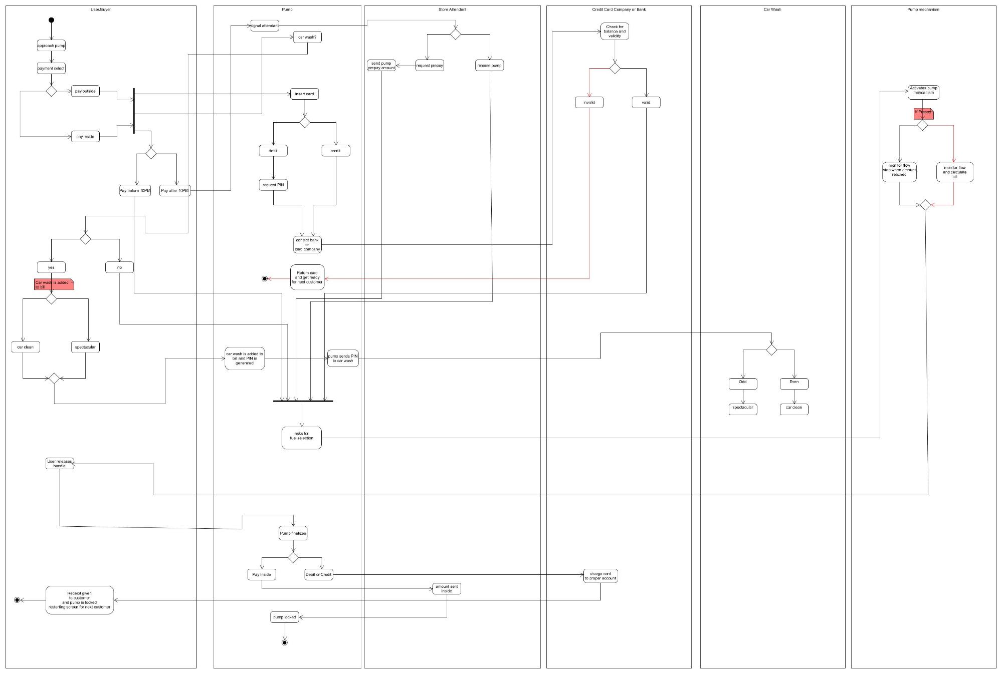

User|Buyer

စြpproach pum] Gayon sa

**payment select**

Pump

**al attendan**

gn

X. payoutside

payinside

ay before 10PM |Payate 10P

[ હામ , .િ નાના

contact bank

**StoreAttendant**

**card company**

**Retun Casid and get ready**

**Credit card company or Bank**

Check for balance and validity

**for next customer**

**spectacular**

Car Wash

**User releases handle**

**car Wash is added to મnsed. Pો bill and PIN is pump sends PIN**

**generated to car Wash**

**| "ಇಂ" । 10 at Wash_I**

**asks for**

**( ಈ )**

s en

speဏီcular

**car clean**

Pump mechanism

**Activates pump mehCanism**

monitor flow monitor flow stop wးဇ္ဈount and calculate bill

fuel selection

**Receiptgiven to customer**

Pum

Payinside Debitor Credit

**amountsent**

inside

**charge sent**

**to proper account**

**and pump is locked restarting screen for next customer**

**pump locked**

இ